GENERATION OF SQUARE WAVE USING PROTEUS
AIM:
To write an assembly language program to generate square wave using 8051.
SOFTWARE REQUIRED:
- Proteus 8 software.

PROGRAM
ORG 0000H
UP: SETB P2.0
ACALL DELAY
CLR P2.0
ACALL DELAY
SJMP UP
DELAY: MOV R4,#35
H1: MOV R3,#255
H2: DJNZ R3,H2
DJNZ R4,H1
RET
END
CIRCUIT DIAGRAM:
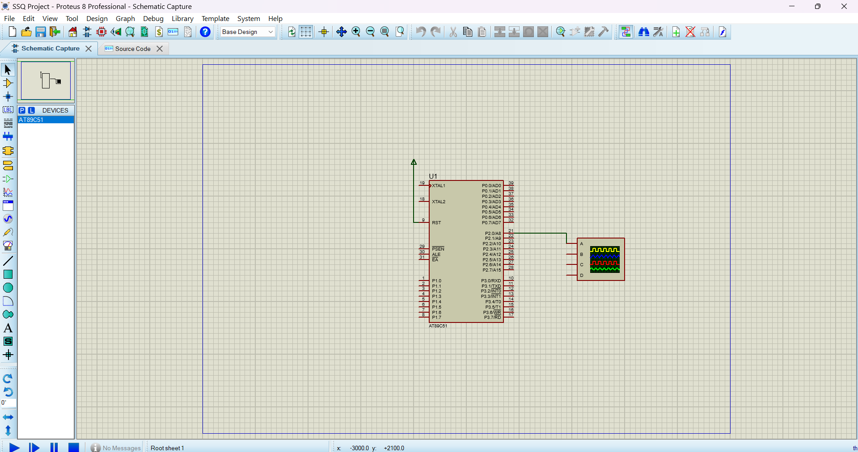

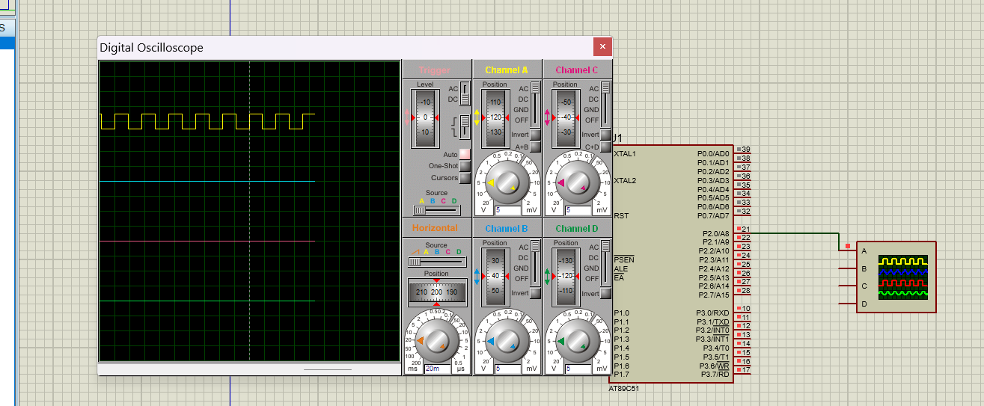
- Adjust the frequency in horizontal and channel A to Observe the square waveform on the oscilloscope for a consistent, symmetrical shape.

